Perfusion platform for bioengineered tissues

Stéphanie Boder-Pasche^{1,*}, Pascaline Sirugue¹, Sarah Heub¹, H. Baris Atakan¹, Jonas Goldowsky¹, Réal Ischer¹, Diane Ledroit¹, Fatemeh Navaee¹, Thomas M. Valentin¹ and Gilles Weder¹

¹ CSEM Centre Suisse d’Electronique et de Microtechnique SA
*E-mail: stephanie.boder@csem.ch

Introduction
Organ engineering and organ-on-chip present great opportunities for drug testing and regenerative medicine. Aiming at mimicking in vivo conditions, perfusion systems are essential to recreate a physiological micro-environment for in vitro tissue maturation. Specifically, unidirectional and continuous medium flow through the engineered tissue is required to provide oxygen, nutrients, and grow a vascularization network. In this context, a platform was developed to perfuse bioprinted liver constructs based on organoid technology as building block for liver tissue transplantation [1]. The system is compatible with multi-well plates and is based on a microfluidic-based “smart lid” for perfusion enabling automated medium circulation, thereby facilitating standardization.

Experimental procedure
The perfusion platform was designed to perfuse six bioconstructs in parallel, continuously flowing cell culture media through the tissue (Figure 1). It consists of six disposable sterile inserts, into which the bioconstruct is printed, and that fit into a standard 6-well plate; a sterile lid with integrated microfluidic features that is sealed onto the substrates and creates a closed perfusion chamber; and a handling platform integrating a peristaltic pump, fluidic and electronic components. Biocompatible materials were used for all parts that are in contact with the tissue and cell culture media.

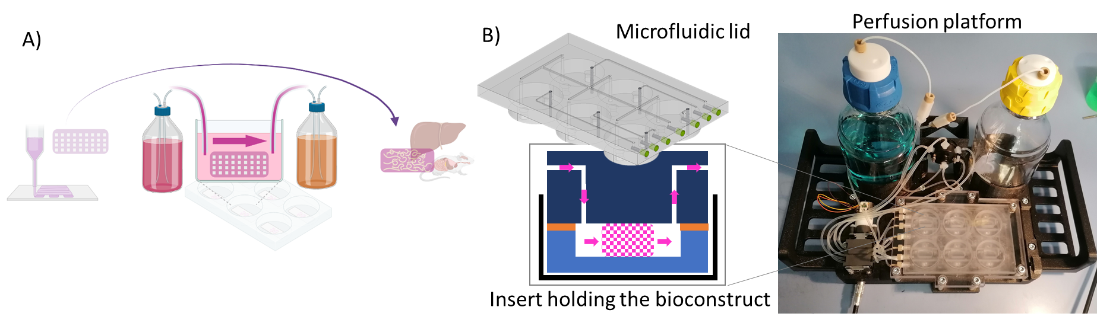 | Figure 1 Concept (A) and experimental setup (B) for the perfusion platform.

Results and Discussion
The perfusion platform enables continuous and unidirectional flow through six wells in parallel, with tunable flow rates ranging from 10 to 500 µL/min without any leakage. Perfusion of 2D cell culture was demonstrated for two weeks in an incubator, to verify the device biocompatibility, showing cell proliferation and no impact on cell viability. Continuous perfusion of six 1x1x0.5 cm³ freshly printed spheroid-loaded bioconstructs with 10 to 50 µL/min of medium is currently being tested and characterized.

Conclusion
The perfusion platform will be used to test and tune the maturation process of liver tissue bioconstructs for several weeks, ensuring a sterile and closed environment. The platform can be adapted to other tissues and geometries, thereby serving both regenerative medicine and drug testing applications.

Acknowledgments
ORGANTRANS project, EU Horizon 2020 research and innovation programme (grant agreement No 874586).

References
[1] www.organtrans.eu

